TERASPIN UI / UX

# Index 1

## Title

Energy consumption and Energy intensity inside the organization, based on G4-EN3 and G4-EN5 of the Specific Standard Disclosures (Category Environmental) pertaining to GRI Sustainability Reporting Guide-lines.

## KPI’s to be reported

* Total electrical energy consumed YTD, previous year for same number of days
* Total energy consumption for whole of last and previous year
* Total electrical energy consumed
* kWh per person, YTD and previous year for same number of days
  + Further break this up for office and factory
* kWh per m2, YTD and previous year for same number of days
  + Further break this up for office and factory
* kWh per part produced YTD and previous year for same number of days
* EPI of each of the last 2 completed years against a benchmark EPI (there will be a text for what the benchmark is and why it is selected)

# Index 2

## Title

Total water volume withdrawal from source and total volume re-used and re-cycled, based on G4-EN8 and G4-EN10 of the Specific Standard Disclosures (Category Environmental) pertaining to GRI Sustainability Reporting Guide-lines.

## KPI’s to be reported

* .Total ground water withdrawal in kl
  + YTD, previous year for same number of day
  + Previous two completed years
    - Further break this up into water consumed in green features like Ambiators, green wall, structural cooling etc. and other utility and manufacturing consumptions
* Total rain water harvested in kl YTD, previous year for same number of day
  + YTD, previous year for same number of day
  + Previous two completed years
* Total and6 percentage of water re-cycled in the STP in kl YTD, previous year for same number of day
  + YTD, previous year for same number of day
  + Previous two completed years

# Index 3

## Title

Total GHG emissions, based on G4-EN15 to G4-EN17 of the Specific Standard Disclosures (Category Environmental) pertaining to GRI Sustainability Reporting Guide-lines.

## KPI’s to be reported

* Gross direct GHG emissions(Scope 1)
  + YTD, previous year for same number of day
  + Previous two completed years
* Gross direct GHG emissions(Scope 1)
  + 6YTD, previous year for same number of day
  + Previous two completed years
* Gross direct GHG emissions(Scope 1)
  + YTD, previous year for same number of day
  + Previous two completed years

# About Teraspin



A.T.E. lives by values of sustainability, care, commitment, openness and innovation. We are a group that creates products and technologies – and this requires us to have our own laboratories, assembly and manufacturing

spaces, and collaborative offices.

So, in planning our workspaces in Ahmedabad and in Pune, our aspirations are to create environments that echo our values and enhance our effectiveness at work. We want our offices to be functional – comfortable, user friendly, support

our ‘do-it-yourself’ style, allow people to walk around, talk and work together, without a sense of hierarchies.

The aesthetic should be ‘unfussy’ – with clean lines, durable finishes, and– to borrow a phrase from Einstein – “everything should be as simple as possible but no simpler”.

As a firm designing thoughtful and high tech products, we need spaces to work in that are open, foster collaboration, enable prototyping and testing and can be reconfigured if needed. Of course, we want to be environmentally conscious and showcase our own ideas and our own ‘green’ products for health and comfort.

We are so happy we could assemble a team that is diverse in skills but unified in purpose, so as to get to our goals.

– Anuj Bhagwati

The TeraSpin | A.T.E. facility is designed with the highest standards of energy efficiency. Energy consumption in the production processes are continuously monitored and efforts taken to systematically reduce the energy consumed in

the manufacture of each product.

The office is similarly designed with the motive to provide comfort as well as reduce the energy footprint. New technologies have been integrated to create a working environment that is comfortable as well as energy-efficient.

The “mixed-mode” air conditioning system, which permits both natural ventilation and mechanical cooling, helps achieve the brief of a seamless working environment. The maximum temperature complies with the recommendations of ASHRAE’s Adaptive Model of Comfort and is designed not to exceed 28°C inside the office space during the peak of

Ahmedabad’s summer.

Air-conditioning systems in an office building of this size in a hot and dry climate zone like Ahmedabad alone can consume more than 85% of the total energy used annually. The building design itself incorporates several features that reduce the energy consumed by the air-conditioners. Passive features such as the reflective mosaic roof and green wall

on East and South façades reduce the energyspend by about 10%. Extensive use of daylight reduces energy use in lighting. Using LED fixtures instead of conventional lighting systems reduces the energy spend by another 1.5%. The unique structural cooling system also reduces energy spend by reducing the quantity of water lost by evaporation. The

biggest energy reduction measures are the use of Ambiators. These machines based on novel indirect evaporation cooling technology can save more than 40% of the energy consumed by conventional refrigerant-based air-conditioners. Since the Ambiators work on fresh air, they ensure a fresh working environment with healthy acceptable levels of carbon dioxide and free of odours. Ambiators are also an A.T.E. group product designed and built by A.T.E | HMX Rigorous computer building energy models estimate that these measures should help reduce the energy use intensity (EUI) by almost 40% from 145 kWh/m2-year (46 kBTU/ft2-year) to 90 kWh/m2-year (29 kBTU/ft2-year) and that

the office building will annually consume about 63,250 units of electricity. Over the last year, the building performance has confirmed building modeling estimates, with an achieved energy performance index (EPI) of 78 kWh / m2 / year, making this one of the most energy efficient offices in India.

# Feature 1

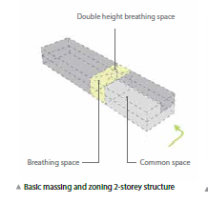The ground floor of the building is divided into

two distinct zones with a double height “lung”

in the middle connecting the two.

# Feature 2

According to the Energy Conservation Building

Code of India, a west-facing overhang with

a 0.35 projection factor (i.e. the ratio of 3.5

meter internal clear height height to a 1

meter overhang), provides a 20% reduction in

solar heat gain, as compared to an unshaded

window.

The 1 meter overhang is incorporated on

the eastern and western facades, while the

northern facade is well protected with a

covered drop off porch.

.

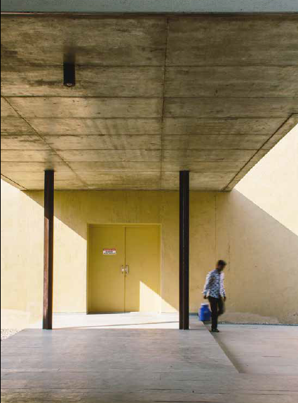 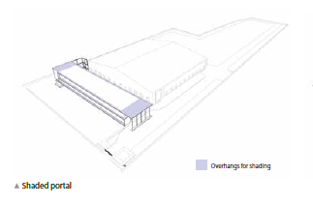

# Feature 3

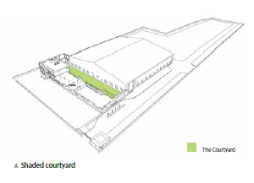

The office and factory building share a common

internal courtyard which is a combination of

soft landscaping and paved areas, interspersed

with shade loving trees. Ensuring that this open

to sky area remains shaded for the majority of

day is critical to the usability of this space. In the

morning and evening the office building to the

east and factory building to the west effectively

shade the courtyard. Around noon when the

sun is overhead, overhangs of the office building

and trees planted in the courtyard shade

approximately 75% of the paved area.

Shading effect of the adjacent factory building

to the west was considered to effectively reduce

10% of solar heat gain to the west side facade

of the office building, according to the glass

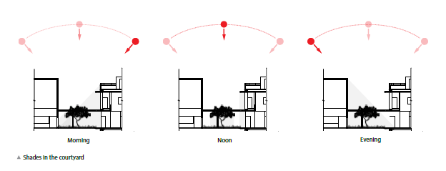specification report of Saint-Gobain Glass.

# Feature 4



Passive ventilation is the movement of

air through a building without the use of

externally supplied energy. Integration of this

phenomenon during the design process of the TeraSpin | A.T.E. office has ensured that non-airconditioned spaces remain cool, thereby saving energy and providing a comfortable working/ environment.

Circulation passages and the “lung” have been provided with large openings along the east and west façades. Therefore, cool air of the courtyard enters the “lung”, picks up the heat from within the building and is pushed out from the openings along the east facade. The continuous movement of fresh air and helps in providing a healthy atmosphere which is cool and comfortable for users.

# Feature 5



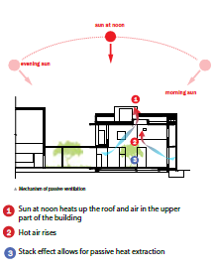The central double height space which lies between the public and private zones of the building is the “lung.” The lung is connected to the factory via a covered walkway through the internal courtyard, while a light metal staircase provides a vertical connection to the first floor.

The lung is a composed indoor-outdoor space, closed from three sides and open towards the internal courtyard. Three façades of the lung are detailed with strategically located openings, while the roof is punctured by two large elliptical skylights. Various openings on multiple surfaces encourage for cross ventilation, thus keeping the space passivley cool, eliminating the need for fans or air conditioning.

A large square planter is located near the center of the lung at the ground floor, and a second larger planter is located on the first floor. The incorporation of dense landscaping within the heart of the building further cools the space, while at the same time blurring the boundary between inside and outside.

# Feature 6



The green wall is a vertically landscaped façade consisting of aluminium trellis panels upon which multiple species of flowering creepers grow. This organic external shading device is incorporated on the east, south, and north facades, so as to prevent direct solar heat gain in the adjacent office spaces.

According the glass specification report of Saint-Gobain Glass, the green wall effectively reduces 30% of solar heat gain – thereby reducing the need for mechanical temperature control within the office.

# FEATURE 7

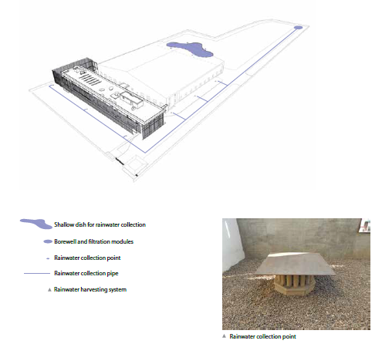

The manufacturing processes at the TeraSpin | A.T.E factory do not require water. Hence water is only required for the use of employees and landscaping. In addition, efficient air-conditioning systems use water chillers and cooling towers to exhaust heat from indoor spaces to the outside. Since the site is spread over a large area, and water consumption is only restricted to a few areas, A.T.E. took on the challenge to make the TeraSpin site a net-zero water site, i.e. the site does not consume more water than it “produces”, thereby reducing its footprint on the environment.

The designers developed a “water balance diagram” for the site to quantify the water use in each area — water consumption. The size of the required air-conditioning system was aggressively reduced by incorporating passive

cooling systems to reduce the heat load in the spaces to be cooled. The office building is rectangular with the south-facing sides smaller and without windows. The white mosaic roof reflects most of the solar radiation. The east and south walls have a “living” green façade that reduces solar heat gain. The factory building shades the major portion of the west wall.

In addition, the roof and other slabs in the office building are embedded with pipes filled with slowly-flowing water. The water in this “structural cooling systems” extracts heat from the building and dissipates it into the ground when the water is stored overnight. These measures reduce the power that may have been consumed by a larger air conditioning system.

Low-water fixtures are installed in wash areas, toilets and pantry areas to reduce water consumption. Finally, a sewage treatment plant with state-of-the-art membrane-based ultrafiltration treats all water to remove all traces of chemical and biological impurities. Thetreated water is recycled for landscaping use.

A sophisticated rainwater harvesting system over the entire site collects rainwater from building roofs and paved areas, filters this water and then, recharges the ground. Based on design calculations, the average water consumption on the TeraSpin site is estimated to be 7,500 m3 annually, and the water “produced” by rainwater harvesting is estimated to be in excess of 8,600 m3 — about 15% higher than that consumed.

# Feature 8

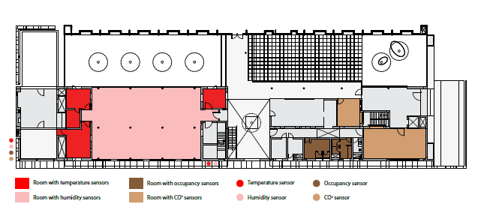

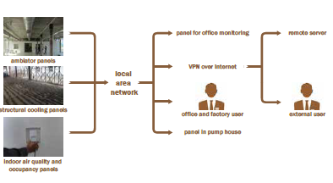TeraSpin | A.T.E. desire is to continuously measure and verify various aspects of the building performance and operation to facilitate quantification of energy used and conserved. TeraSpin | A.T.E. also uses this system to monitor equipment manufactured/used by A.T.E. group companies for design verification. These aspects are broadly classified as:

1. Electrical energy consumed by lighting and factory loads.

2. Electrical energy consumed by cooling loads like Ambiators and structural cooling pumps.

3. Indoor Air Quality (IAQ) parameters like CO2 levels, temperature and humidity at specific points in the factory and the office.

4. Water consumed and re-used in the facility. The solution is broadly classified as hardware needed for data acquisition and a remote server based software for storing and viewing data, reports and notifications. The monitoring requirements proposed here-in cover parameters from proposed analytics perspective too.

The remote server hosts the software for data storage and display. The users can log on to the server using a standard web browser. They also get alerts and maintenance acts over SMS/email. (EcoAxis)